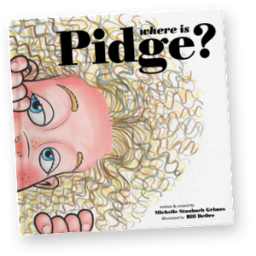

**Where is Pidge?**

**Created by: Michelle Staubach Grimes**

**Illustrated by: Bill DeOre**

**www.whereispidge.com @whereispidge**

Book Order Form

**Student Name _____________________________________________________**

**Teacher _______________________ Grade ­­­­­­­­­­­­­­­__________________**

**Parent Name __________________________________________________**

**Parent E-mail _____________________________________________________**

**Each book is $16.95**

© 2015 Pidge Media, LLC. All rights reserved.

**Book 1: NO Signature Signature Personalized**

**Name for personalization _____________________________________________________________**

**Book 2: NO Signature Signature Personalized**

**Name for personalization _____________________________________________________________**

**Book 3: NO Signature Signature Personalized**

**Name for personalization _____________________________________________________________**

Qty:

TOTAL:

For office use only— Method of Payment:

Cash

Check—made out to: ________________

Processed by: _____________________

Use the reverse side for additional book inscriptions.

**All orders due by __________.**